Team: The Green Machine

Sustainability Pledge Website

Final Report

Features Implemented:

* Save users’ information to database
* Save users’ input for Get Involved page into database
* User verification via email
* Revamp the UI
* Bootstrap Navigation Bar
* Added information tabs: News, Past Events, Profile
* Implemented admin privileges to users
* Admin tab is properly routed for users that are admins
* Pledge behavior (show one at a time) and answer options

Features to be done:

* Implement admin view and query database information (users’ and Get involved info)

Known Issues:

* Because the way the system saves the users at login to the database, every time you login the admin privileges get reset to false.
* At time of deployment the pledges are aligned to the very left edge of the screen
* The pledges don’t show the past users responses since implementation was changed

Project Flyer

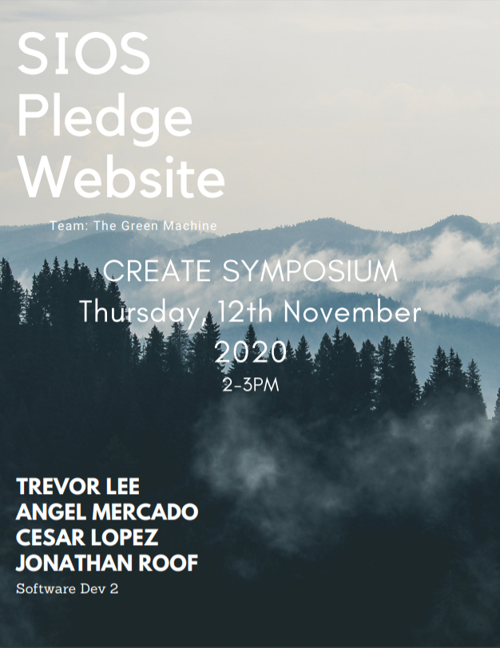

Live Demo:

[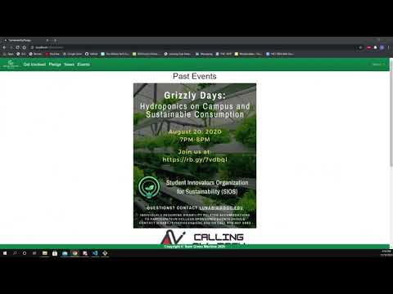](https://www.youtube.com/embed/a9Ixflzd_Ko?feature=oembed)

The Green Machine Members:

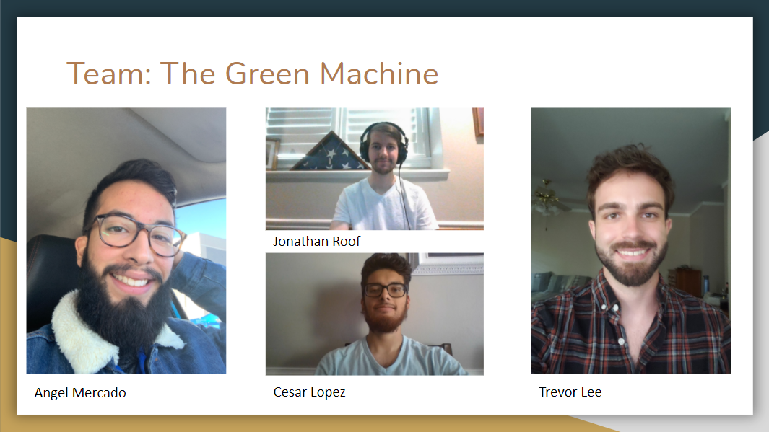

Client:

Must contain:

* provide a short screencast demoing your product live (prefer a screen recorder with voiceover rather than a hand-held camera). Upload it to Youtube and provide a link. Here's an example.
* team members' introductions and selfie/group photo. Photo of the client with a brief bio.
* testing coverage, methods, and results
* usability testing and focus group survey results (see [example survey](https://www.surveymonkey.com/r/X22YHJ9))
* where to find installation, developer, and user documentation
* software usage license and intellectual property terms, including a signature page with all team members and client ([example IP that includes two successive teams](https://ggcedu-my.sharepoint.com/:b:/g/personal/cgunay_ggc_edu/EdyubF18saBFpK4e-rS78z4BOwIxSgkJuL-iQ5kymX_NEQ?e=xdPRhL)). For generating a license, you can use [Creative Commons](https://creativecommons.org/share-your-work/) or [Binpress](https://www.binpress.com/license/generator" \t "_blank).